**4 Evaluation**

1. Pre Part1. To find the suitable number of particles per edge (n) for COMSOL setting.

From the plot we can see that, the K result does not vary too much starting from n = 4 to n = 10. The suitable number of particles per edge is around n = 5 and n = 4 is a suitable size which gives converged results while cost relatively less time.

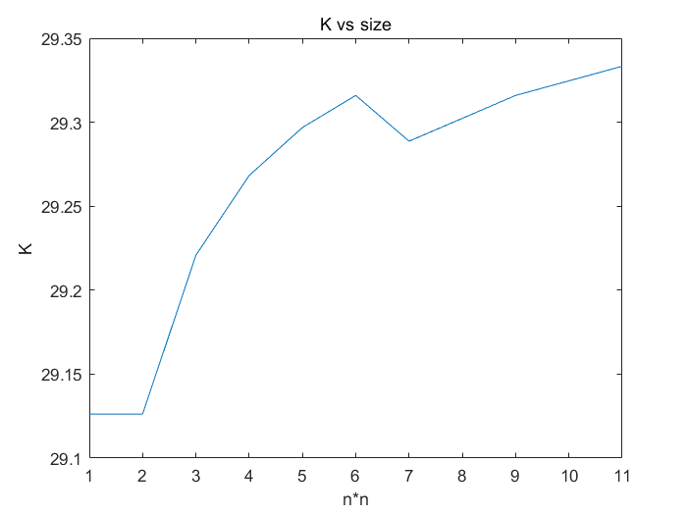

1. Pre Part2. Compare ML model with the Nan’s formula.

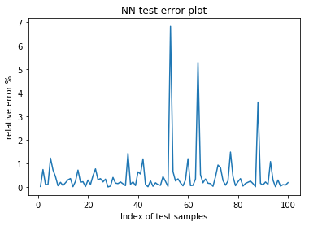The maximum relative error between ML model and Nan’s formula is around 7% which happens at low K result area. This is because, for the low K, even a small deviation will cost a large relative error. In the area of Normal K area, the relative error is less than 1%, which is an acceptable result.

Top 5 error samples:

1: error: 6.831268

[43.7035, 2.1519, 0.3617, 0.9119, 1.1429]

2: error: 5.292724

[43.4833, 2.7735, 0.1217, 0.9848, 0.75]

3: error: 3.606294

[79.5504, 3.2859, 0.0448, 0.9957, 0.8571]

4: error: 1.483032

[20.4486, 24.1336, 0.908, 1.0, 1.0]

5: error: 1.428724

[27.3519, 3.3344, 0.2084, 0.4628, 2.5]

1. Part 1 Compare between the results of Nan’s formula and results of COMSOL simulation.

In this part, we compare the results of Nan’s formula and that of COMSOL simulation to see how good the performance of Nan’s formula is, regarding COMSOL results as the valid experiment values.

Nan’s formula derives in the case where particles are ellipsoids. To begin with, in the ellipsoid test set, both the boundary and misoriented K results match well for different km, kp sets. The Nan’s misoriented results lie between the upper and lower boundaries of the COMSOL results which shows that Nan’s formula can be used in the ellipsoid particle case.

When extending Nan’s formula to particles of other shapes, the results match well in cone and donut cases but not in helix case. In helix case, the Nan’s misoriented results lie under the lower boundaries of the COMSOL results for most the km, kp sets.

(Plots only with FE boundaries and misoriented, and Nan misoriented)

Next, we plot out the root mean square of absolute error for Nan’s formula for different shaped particle cases.

(Plots that only have OLD model with p chosen by human)

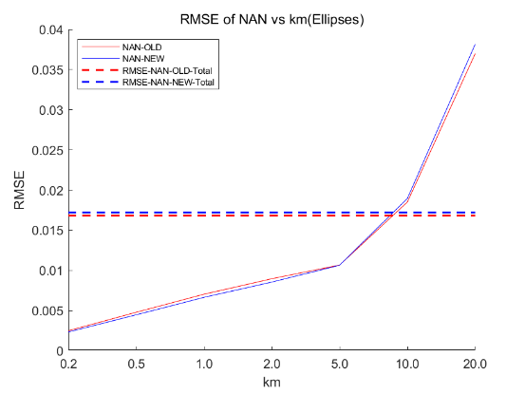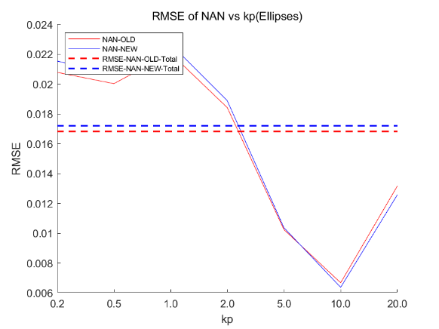

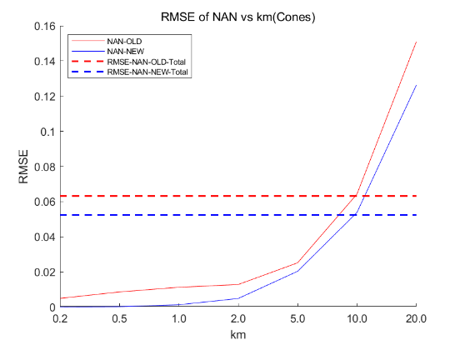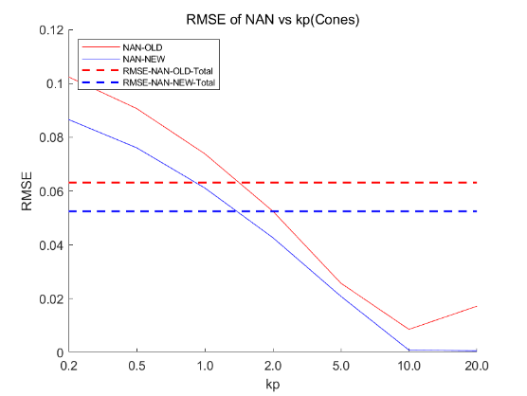

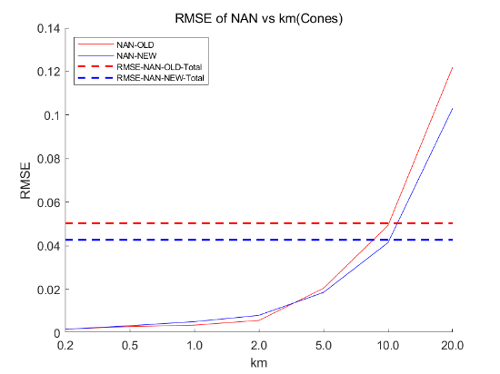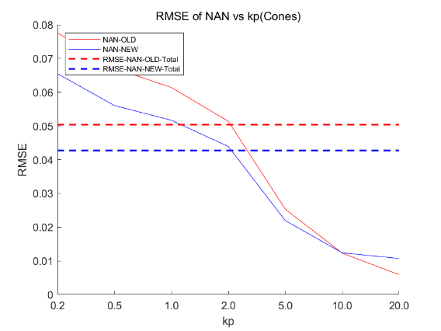

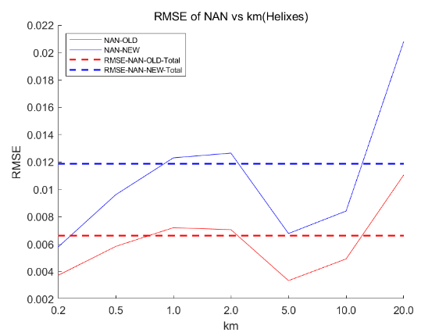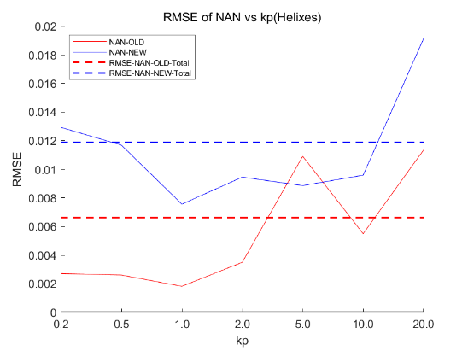

If we can accept Nan’s formula in ellipsoid particle case, the RMSE (Root Mean Square Error) for kp and km are around 0.018, which means that RMSE of order 0.01 can be accepted. The RMSE for other shaped particle cases are around this order, especially in helix particle case where the RMSE is smaller than that in ellipsoid particle case, which makes Nan’s formula a suitable method solving composite material heat conductance in various shaped particle cases.

1. Part 2 Compare between the results of Machine Learning Model predicted (ML) results and results of COMSOL simulation.

In this part, we compare the results of ML and that of COMSOL simulation to see how good the performance of ML model is, regarding COMSOL results as the valid experiment values. As before, we plot out the root mean square of absolute error for ML model for different shaped particle cases.

(plots with only RMSE set without p model)

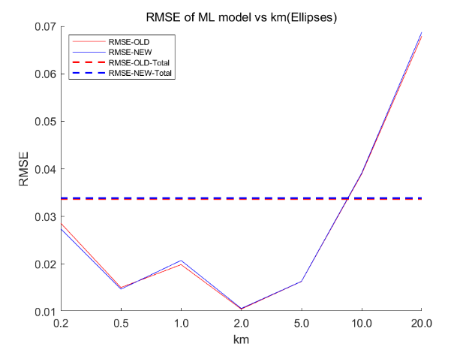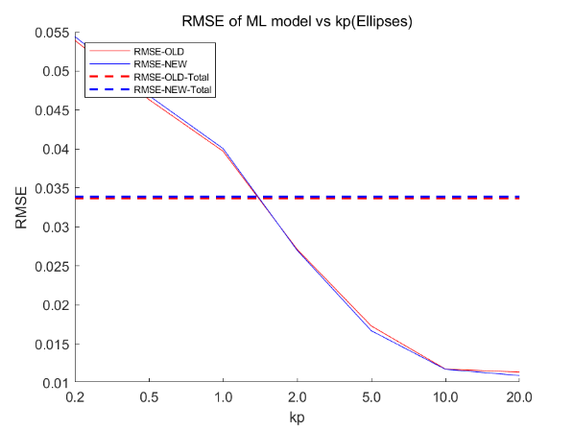

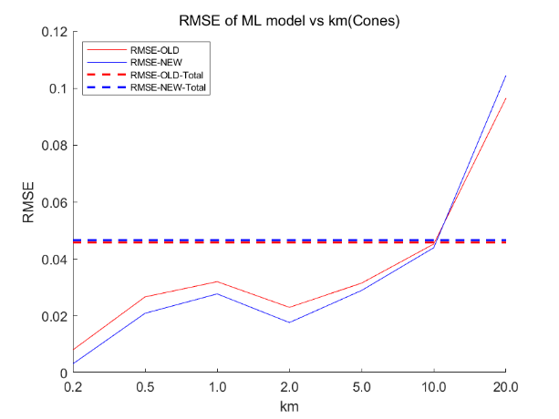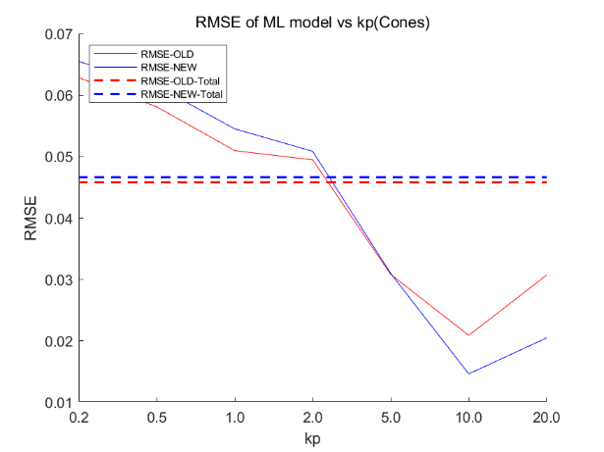

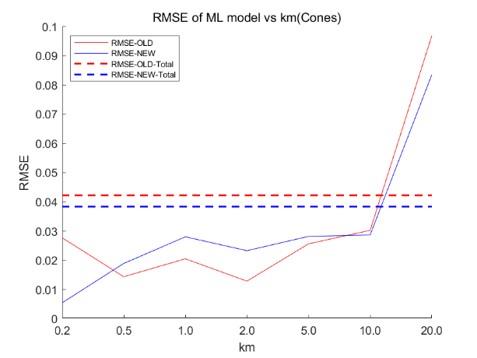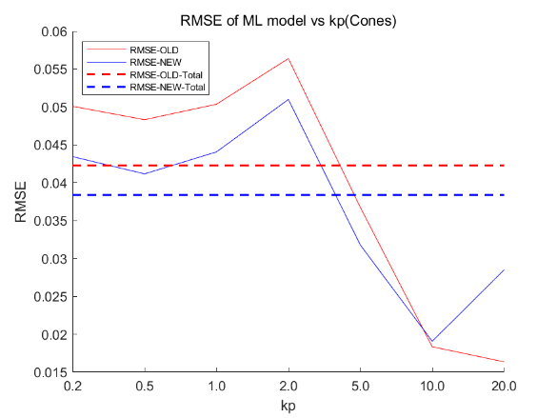

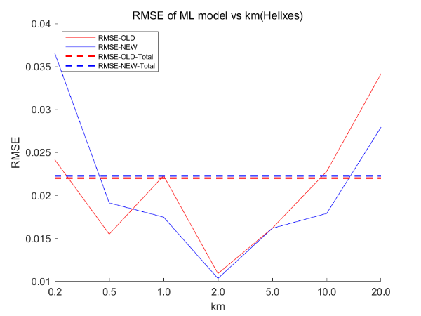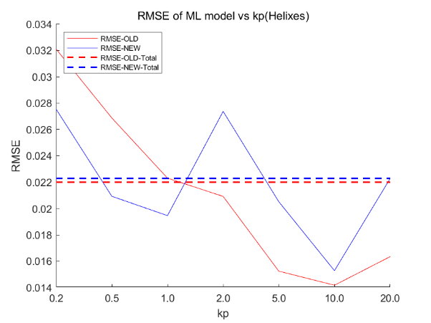

Based on the plots, all the RMSE for kp and km for various shaped particles lies in the range from 0.02 to 0.05 which is acceptable.

1. Part 3 Compare the p model result with the without p model.

(Plots with and without p for ML model)

The problem to extend Nan’s formula to other shaped particle cases is finding an equivalent set of semimajor axis for the new shape, or equivalently a way to find the equivalent factor p in Nan’s formula. Previous plots are plotted with p manually choosing by human. The p model we obtain can always give a p value needed for ML model and Nan’s formula based on the common factors of all shapes.

To verify the validity of p model, we plot out the root mean square of absolute error for ML model with p derived both manually and from p model for different shaped particle cases. From the graphs we can see that the RMSE results are close for various shapes. From some shapes, the result using p model is even better. This indicates that the p model we derive is capable of choosing suitable p for various shapes.

Brief conclusion

We use purely machine learning to build models to calculate heat conductance for different shaped particle cases.

We use machine learning to build a model to mimic Nan’s formula successfully on ellipsoid particle case. Again, we use machine learning to build a model to calculate the suitable p for various shaped particle case based only on common factors for all shapes, so that we can extend Nan’s formula or model derived from Nan’s formula to other shaped particle cases.

**5 Limit**

1. We only perform the simulation on 4 shaped particle cases, which is not enough to demonstrate the completeness of the machine learning models.
2. We only perform the simulation on experiment sets with limit particle volume fraction. Also, the particle volume fraction cannot be made too high in COMSOL simulation. We cannot demonstrate the validity in high particle volume fraction cases.
3. In small kp and km cases where the K results are small, if high precision is required, the machine learning model does not perform well.